Table of Contents

What is Ed-Fi? 2

What is the Student Reconciliation Tool? 2

How Does StudentReconTool Work? 3

How Can you Use StudentReconTool? 4

Special Features 6

Pagination 6

Deleting Unwanted Records at the State: 6

Questions and Feedback 9

# What is Ed-Fi?

Ed-Fi is short for “Ed-Fi Alliance”, which is a non-profit educational organization sponsored by the Michael and Susan Dell Foundation (of Dell Computers fame). It is a system for capturing and managing student- and school-centric information, and is free to any state that wishes to implement it.

The Ed-Fi system provides a technology foundation that includes several hundred data models for handling education-related data. States can implement the “core” Ed-Fi system as much or as little as they need, and have the ability to create “extensions” to the core system that provide additional capabilities specific to that state. By separating the core system from a state’s extensions, a state can customize Ed-Fi in such a way that no code modifications should have to be made to the core system. This in turn allows Ed-Fi to continue to provide updates to the core system without breaking a state’s customized extensions.

Included with the Ed-Fi core system is a way of sending data to, and receiving data back from, the state’s data store. Ed-Fi uses a state-of-the-art web-based “window” called a REST API to handle this two-way communication. If you are in an Ed-Fi enabled state and have a local Student Information System (SIS), then your SIS will be using this REST API to send and receive data.

Want more information about the Alliance? Here is the link to their website: <http://www.ed-fi.org>

# What is the Student Reconciliation Tool?

The Student Reconciliation Tool (StudentReconTool) is a web-based application that provides a set of tools designed to help LEAs (Local Education Agencies) reconcile data between their local SIS and their state's Ed-Fi data store. It was designed by individuals with extensive understanding of the Ed-Fi REST API as implemented by the Arizona Department of Education.

Among other features, it presents student, school, staff, and parent information in a way that helps the LEA compare the information that exists at the state level with the information stored in the LEA’s local SIS. It uses the same REST API as your local SIS to retrieve information from the state on your behalf. And because it is completely independent of your local SIS, no customization of your SIS is required.

The current version offers the following features:

* Uses an HTTPS secure connection to protect your data.
* Look up information for a given student.
* Look up information for a given school, such as course offerings and sections.
* Look up information for a given staff member.
* Look up information for a given parent.
* Look up information for prior years, providing the LEA has the proper permissions from the state to do so.
* Paginate through large volumes of information such as course offerings and sections.
* Delete records from the state data store which you do not show in your local SIS and should not exist at the state level.
* Cross-reference students, schools, staff, and parents by clicking on their respective unique ids.
* Uses the LEA’s existing API key and secret (equivalent to a user name and password) that you already use to send data to the state.
* The student, school, staff, or parent id can be included as part of the Url address, immediately focusing on that specific id's information. This provides an optional direct link that SIS vendors can someday use to quickly pull up information so you can easily compare what you have in your local SIS with what the state data store shows.

Features being considered for future versions include:

* Import a list of students, schools, staff, and/or parent all at one time.
* Export results to a file using one or more formats.
* Import information directly from the local SIS, allowing the tool to handle most of the reconciliation automatically (this will require coordination with each SIS vendor).
* Search filters to help narrow down searches results.

# How Does StudentReconTool Work?

When your local SIS sends data to the state, it uses the web-based Ed-Fi REST API to do so. Your SIS passes the data along with a username and password called the “API key” and “secret”. These “credentials” were assigned to you by the state and are specific to your LEA. They provide a security check that ensures you have the proper access to your designated schools, students, and so on while also protecting your private information from improper access from other persons.

StudentReconTool uses the same REST API as your local SIS to access your data at the state. You simply point your Internet browser to the tool, pass your API key and secret as part of the Url address, and optionally include your search parameters. The tool does the rest. See examples later in this document on different ways you can customize the Url address.

Using your same API key and secret allows the tool to access your data on your behalf. Since the REST API handles all security concerns, StudentReconTool will only access information you are authorized to view.

Once the tool has displayed the information you’ve requested, it provides cross-links to make it easy to view other associated information. For example, once you view a student, there will be links to that student’s responsible parties as well as to the school(s) the student is associated with. From there the possible combinations are endless. School information can lead to staff or other students, and so on.

# How Can you Use StudentReconTool?

As mentioned previously, StudentReconTool is a web-based application. To use it, you point a browser to the tool and include in the Url address, your API key, and secret. You can optionally include your search parameters (student id, school id, etc.) in the Url address. The tool validates your request and presents the results.

Here are different ways you can compose the Url address to achieve different results:

1. The basic format:

<https://studentrecontool.com/?apikey=aaaaaaaaaa&secret=bbbbbbbbbb>

where aaaaaaaaaa is your API key and bbbbbbbbbb is your secret. The tool will validate your API key and secret, and present you with the default screen shown below. From here you can enter a student id, or navigate to other tabs to view school, staff, and parent information.

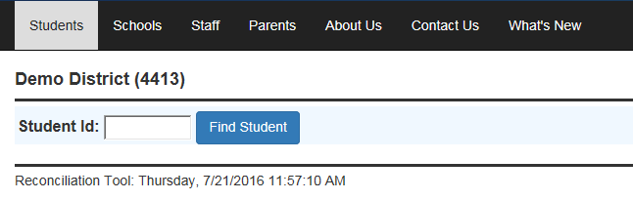

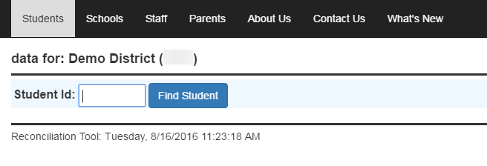

1. You can specify the student id as part of the Url address:

[https://studentrecontool.com/?apikey= aaaaaaaaaa &secret= bbbbbbbbbb &studentid=11111111](https://studentrecontool.com/?apikey=%20aaaaaaaaaa%20&secret=%20bbbbbbbbbb%20&studentid=11111111)

where 11111111 represents the unique student id

The tool will present a screen similar to this one:

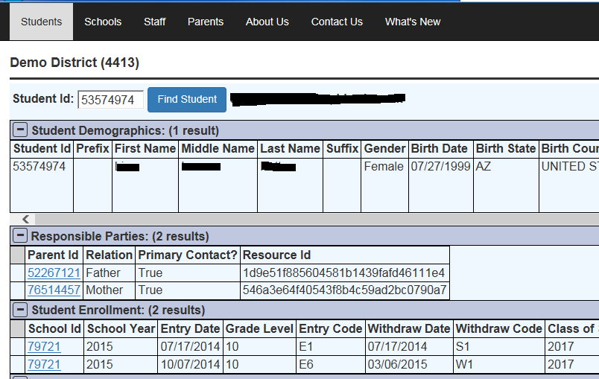

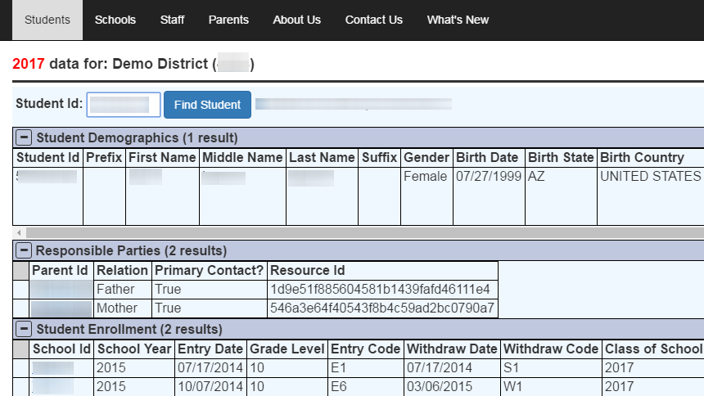

1. Similarly, you can specify the school id, staff id, and parent id:

[https://studentrecontool.com/?apikey= aaaaaaaaaa &secret= bbbbbbbbbb &schoolid=11111111](https://studentrecontool.com/?apikey=%20aaaaaaaaaa%20&secret=%20bbbbbbbbbb%20&schoolid=11111111)

[https://studentrecontool.com/?apikey= aaaaaaaaaa &secret= bbbbbbbbbb &staffid=11111111](https://studentrecontool.com/?apikey=%20aaaaaaaaaa%20&secret=%20bbbbbbbbbb%20&staffid=11111111)

[https://studentrecontool.com/?apikey= aaaaaaaaaa &secret= bbbbbbbbbb &parentid=11111111](https://studentrecontool.com/?apikey=%20aaaaaaaaaa%20&secret=%20bbbbbbbbbb%20&parentid=11111111)

These Url addresses will result in the tool presenting the appropriate page similar to the student page

1. With authorized permission from the state, you can also access prior year’s information by specifying the year as part of the Url address. Note that StudentReconTool defaults to the current fiscal year:

[https://studentrecontool.com/?apikey= aaaaaaaaaa &secret= bbbbbbbbbb &year=2016&schoolid=11111111](https://studentrecontool.com/?apikey=IB1LWwXhZhpm&secret=gCUM4lHeLAVVbLSL6mmkLsrI&year=2016&schoolid=79721)

# Special Features

StudentReconTool provides some features that merit special explanation:

## Pagination

The REST API returns a maximum of 100 results for any one resource type requested. This is to prevent “runaway queries” that might otherwise return thousands of results, impacting REST API performance. For example, a school may have several hundred course offerings. Only 100 course offerings are returned at a time, although the REST API also provides an “offset” parameter to allow access to course offerings 101-200 (and so on). To “play nice” with the REST API, StudentReconTool honors this 100 maximum and provides a way to page thru the data. See the screen shot below. **NOTE:** The REST API does not return the number of pages or available results, so it is not currently possible to jump to the end of the list. One possible solution being looked at is to provide search filters that will help zoom in on the specific subset of data the user wishes to view.

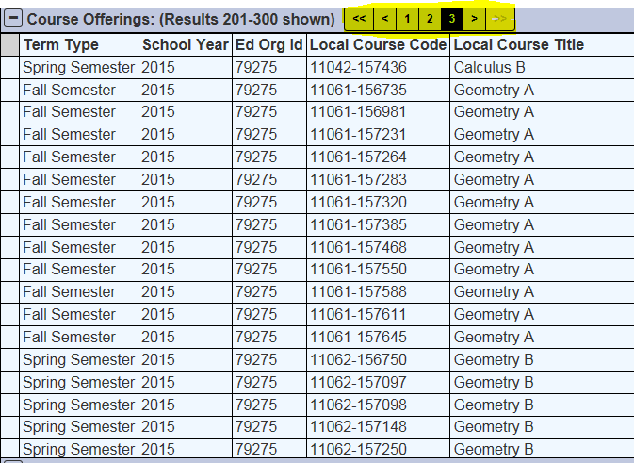

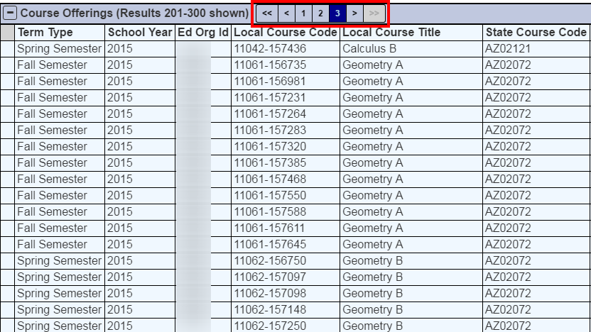

## Deleting Unwanted Records at the State:

One of the most frustrating problems reconciling your SIS with the state data store occurs when extra data somehow ends up at the state that the local SIS has no knowledge of. This can happen for a number of reasons:

* A bug in the SIS that did not delete old data when new updated data was sent
* Internet connection problems
* Hardware/software issues at the SIS or state level
* Attempts by the state to help correct an LEA’s data

Regardless of how the problem occurs, it can be frustrating to the LEA because it has no way to delete the unwanted data. While the state may be able to help by manually deleting the data on behalf of the LEA, support backlogs can sometimes delay the solution being implemented.

StudentReconTool helps by taking advantage of how data is stored via the REST API. Nearly every record you send to the state is assigned a unique identifier called a “Resource Id”. This resource id is guaranteed to be unique, and becomes a “handle” by which each record can be retrieved, updated, or deleted. Here is a screen shot showing sample course offerings and their respective resource ids:

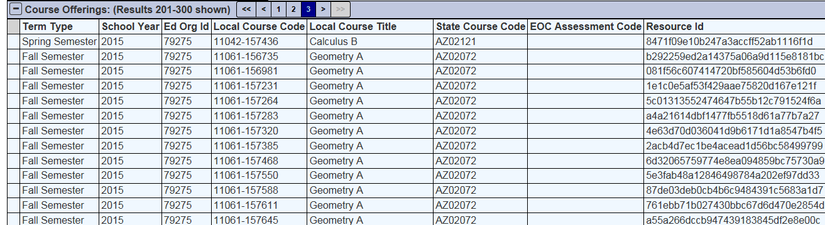

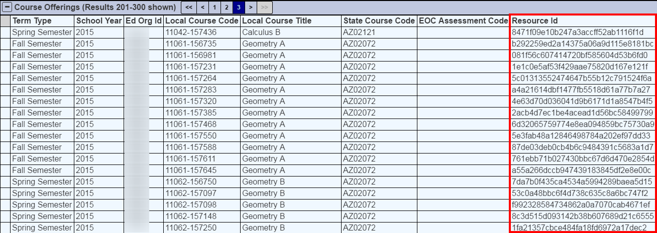

The REST API provides ways to access each record by their resource id. StudentReconTool facilitates deleting unwanted records by allowing the LEA to select rows it wants to delete, and then instructing the tool to send delete requests to the REST API.

This process only requires a few steps, but is intentionally designed to prevent accidental deletion of data. To delete one or more rows, note the empty column at the far left side of the table, highlighted in yellow:

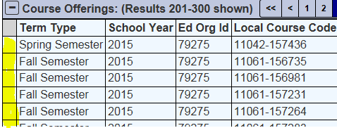

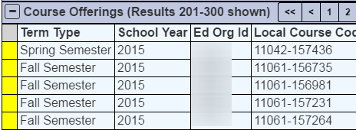

If you click on the empty column, that row gets selected. You can select more than one row; you can even select rows in other tables on that page. Here is an example of two course offerings being selected for deletions:

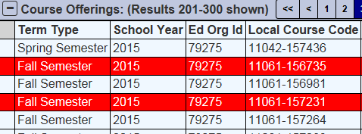

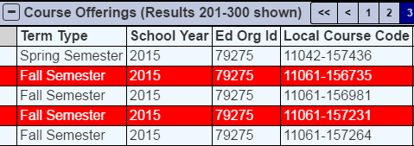

Next, if you right-click on the page, you see the following menu:

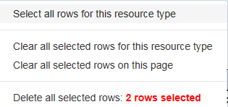

The options presented are:

* Select all rows for this resource type. In this example, every course offering shown on the page will be selected.
* Clear all selected rows for this resource type. This unselects all course offerings, but leaves any selected rows in other parts of the page alone.
* Clear all selected rows on the page. Unselects all rows, regardless of where they appear on the page
* Delete all selected rows: 2 rows selected. Clicking this menu choice results in the following confirmation message box being shown

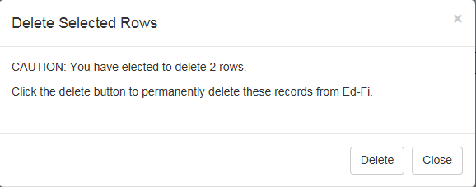

Clicking the “Delete” button will cause the tool to send delete requests for each row selected. It will then update the page accordingly.

# Questions and Feedback

We appreciate your questions and feedback. Please feel free to send them to us at [support@studentrecontool.com](mailto:support@studentrecontool.com).